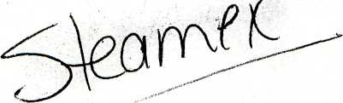

CHEMSPEO
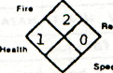
CHEMICAL SPECIALTIES MANUFACTURING CORP. 3001 E. Madison Street - Baltimore, Maryland 21 205 - Phone (301) 675-4800
MATERIAL SAFETY DATA SHEET
HAZARD RATING:
* - EXTREME
3 := HIGH
2 = MODERATE
1 - SLIGHT
0 -- INSIGNIFICANT

I PRODUCT IDENTIFICATION

chemical name and synonyms
CHEMICAL FAMILY

TRADE NAME AND SYNONYMS
NON-RESIDUE *ROTOBRITE

HAZARDOUS INGREDIENTS

MATERIAL OR COMPONENT
HAZARD DATA

- 2-Butoxyethanol CAS FN 111-76-2
Propylene Glycol Monomethyl Ether CAS PN 107-98-2
V ^{50ppm-} ^{r}°^{axic} by skin absorption. Moderate irritant eye and ingestion.
Flammable. Fl. pt. 100°F. Higher levels-anesthesia effect.

Ill PHYSICAL DATA
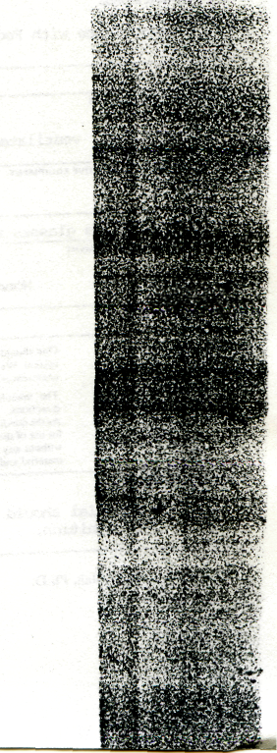

•OILING POINT 7H MM HQ | Approx. 212°F | MELTING POINT _{H}/» 1 PH = 10.4 ~ 11
specific gravity | 0.94 | vai-or prissum similar to vrater
VAPOR DENSITY (AIM - 1) | Approx. 0.8 | SOLUBILITY IN M_{Z}O. % Vt WT. nil .„,-,., 1 !. ,,.^
% VOLATILE S IV VOL | 99 | EVAPORATION RATf (»UTVL ACETATI - 1) 1.1
APPEARANCE AND ODOR | Clear colorless liquid - low odor
IV FIRE AND EXPLOSION DATA

FLASH POINT {TEST METHOD) | 142°F (TOG) | AUTOIONITION  TEMpfBATURi None
FLAMMABLE LIMITS IN AIR. X BY VOL LOWER NODS |  | 1 orreii | None
EXTINGUISHING MEDIA | Will not burn in diluted condition
SPECIAL FIRE FIGHTING PROCEDURES | N/A
UNUSUAL FIRE AND EXP10SION HAZARD | None
V HEALTH HAZARD INFORMATION
HEALTH HAZARD DATA
ROUTES OF EXPOSURE INHALATION . -, , SKIN CONTACT
May cause drowsiness N&y be irritating
SKIN ABSORPTION J^y J^g tQXJ.C ^{EYE} |  | CONTACT _{Irritating}
May cause nausea
70
V HEALTH HAZARD INFORMATION — Continued

ECTS Of OVERtxPOSUfif _ ,- , •
acute ovfH*xposu«F Drowsiness, fatigue
ovehexposube
EMERGENCY AND FIRST AID PROCEDURES
^{[yts} Flush w/water for 15 minutes
«HALAT,ON
NOTES TO PHYSICIAN
to avoid
0
Wash with water
t induce vaulting. _wnr-pr or m]Tk.

VI REACTIVITY DATA

CONDITIONS CONTRIBUTING TO INSTABILITY
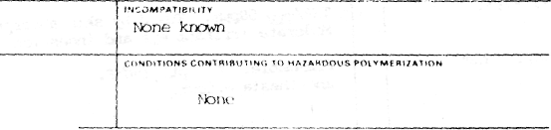
Stable
HAZARDOUS DECOMPOSITION PHODUCTS
When heated to decomposition, onits acrid smoke and irribntirKj fumes.

VII SPILL OR LEAK PROCEDURES
Dilute with water and flush down sewer if permitted by Federal, State or local regulations.
NEUTRALIZING CHEMICALS
None required
WASTE DISPOSAL METHOD
In accordance with Federal, State or Local regulations.
VIM SPECIAL PROTECTION INFORMATION
VENTILATION KCQUIAf MENTS
Work in well ventilated area

SPECIFIC PERSONAL PROTECTIVE EQUIPMENT | Avoid breathing vapor. Use m^^ if nef^^ry . | NIOSH approved
Goggles or eye glasses with side shields | GIOVES  Impermeable gloves
None
IX SPECIAL PRECAUTIONS
One should always use chcmicaK with an awarenes.s of the potential ha/ard (known jnd unknown) of :hcn effect on the human system. We urge user*, to minimi/e employee exposure id all chemicals, including this product, and to keep the level of exposure commensurate with good industrial hygiene practices.
Disclaimer of Liability The manufacturer and seller warrants [hat thi;: product conforms to its standard specifications wh<n used according to
directions.
As the condflior,'; or n;t.-(iit>ua cf ua^ ire bcynntf our control, we do no! assume any responsibility and expressly disclaim any liability for use of this product. Information contained herein is believed to be true and accurate but all statements or suggestions are made without any warranty, expressed or implied, regarding accuracy of the inforniamwi. the hazards connected with the use of the material and the results to be obtained from the use thereof.
OTHER PflECAUflONS
Material should be placed away from boated surfaces and sources of ignition.
PRECAUTIONARY STATEMENTS

Prepared by Aziz Ullah, Ph.D.
Date
November 22, 1985

