SARGF^T-WeLCH
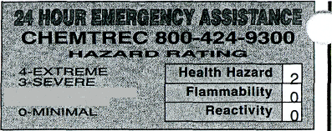
V W Ft i. ! / € N T I F I C
| |
911 Commerce Court • Buffalo Grove • Illinois 60089-2375 1-800-727-4368
i, 2-MODERATE '-• i~1-SU<3HT '
MATERIAL SAFETY DATA SHEET
i
READ CAREFULLY BEFOREiUSING CHEMICAL DSHA requires that this forrn be kept on file.
•roduct No. C4078R
•roduct Name LITHIUM CHLORIDE

• SECTION 1 NAME
."•: Chemical Synonyms | Hydrochloric | Acid, Lithium Salt
ORIDE Formula | LiCI
CAS No | 7447.41 -8  ^{l}»~<«ww*™»w^- «" " ••
?!irei^r^*TPf?*fiTf^{i}?rfTT*fTT*f?™r"«i*

Principal Hazardous Component(s)
TLV Units
N/A
%
99+
P.E.L.
N/A
Jthium Chloride

HEALTH HAZARD DATA
SECTION V
Threshold Limit Value * > 3 :~.
No applicable information was found.
Effects of Overexposure
May be irritation to eyes and slightly irritating to skin, nose and throat. No significant toxicity hazard in small doses. Relatively large doses cause minimal signs of toxicity, primarily gastrointestinal upset.
Emergency and First Aid Procedures
Eyes: Flush with water for 15 minutes. If irritation occurs and persists, obtain medical attention. Skin: Wash with water. If irritation occurs and persists, obtain medical attention. Inhalation: Remove to fresh air. If discomfort occurs and persists, obtain medical attention. Ingestlon: Drink plenty of water and induce vomiting by touching the back of the throat with a finger, or if available, by administrating syrup of ipecac. Do not induce vomiting or give anything by mouth to an unconscious person. Obtain medical attention.

Stable
Stability
Unstable Q
Conditions to Avoid
None

_* chemical subject to the reporting requirements of SARA TitleJII.
k"^
Incompatibility (Materials to Avoid)
Strong acids.

2,1 a/cc
Upper
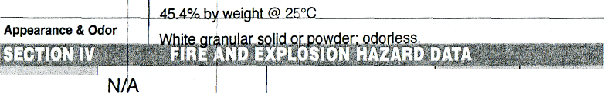
Melting Point (°F)
Specific Gravity (H₂O=1)
Boiling Point (T)
Percent Volatile by Volume (%)
N/A
O17-I °F
Evaporation Rate
Vapor Pressure (mm Hg)
( -1) I N/A
Vapor Density (Air=1)i
N/A
Solubility in Water
Lower
Flammable Limits in Air % by Volume
Flash Point (Method Used)
N/A
Any suited for fjre in surrounding area.
Extinguisher Media

Hazardous Decomposition Products
None
Hazardous Polymerization Will Not r-, Occur ^*»
Conditions to Avoid
N/A

SPILL OR LEAK PROCEDURES
Steps to be Taken In Case Material is Released or i
Sweep up and place in a suitable container.
Waste Disposal Method
Discharge, treatment, or disposal may be subject to Federal, State or Local laws. These disposal guidelines are intended for the disposal of catalog-size quantities only.
Dispose of waste according to federal EPA, state and local regulations.

Special Firefighting Procedures
None
Unusual Fire and Exp osion Hazards |
This product is not an explosive.

Respiration Protection (Specify Type) | No special requirements.
Ventilation | Local Exhaust | X |  | Special
Ventilation | Mechanical (General) |  |  | Other
Protective Gloves | Rubber gloves |  | Eye Protection |  | Safety goggles
Other Protective Equipment | Lab coat. Quick-drench eyewash and |  |  |  | safety shower.
SECTION IX SPECIAL PRECAUTIONS
Precautions to be Taken in Handling & Storing
Keep container tightly closed when not in use.
Avoid contact with eyes, skin and clothing. Store away from strong acids. Wash thoroughly after handling.
Other Precautions ~ ~.
Read label on container before using. Do not wear contact lenses when working with chemicals.
N/A

D.O.T.
NptRequlatsd
Approved by steven C. Quandt Effective Date 05/1094 ElS^'K^^SSSS,

The information contained herein is furnished without warranty of any hind. Employers should use this information only as a supplement to other information gathered by them and mu
—i.- :__i_ !„„. j_.—;_„,:„„ „. „, ,:_{t}^kiiih, ^_{nr}< ^r.m.jQicnacc nf jninrmatinn from all sources to assure orooer use of these materials and the safely and health of employees.

