-W*= LI H
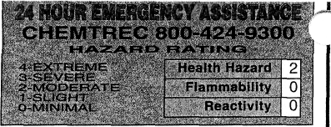
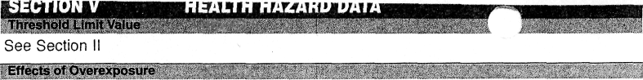
NAME
TLV Units
10ug(Ag)/m³
VWR.'i 1 € N T I F I C
911 Commerce Court • Buffalo Grove • Illinois 60089-2375 1-800-727-4368
IMPORTANT
MATERIAL SAFETY DATA SHEET
READ CAREFULLY BEFORE USING CHEMICAL
SECTION I
OSHA requires that this form be kept on file.
Chemical Synonyms
N/A
Product No. C4577F __
Product _{Mama} SILVER NITRATE
Formula
mixture
0.10 N SOLUTION ' •> / <
See Section II
C.A.S. No.
HAZARDOUS INGREDIENTS OF MIXTURES
SECTION II
Principal Hazardous Components) 'Silver Nitrate CAS# 7761-88-8
N/A
<2
Contact with skin or eyes may cause irritation. Ingestion may cause gastrointestinal pain, nausea and vomiting.
Emergency and First Aid Procedur
Call a physician. EYES/SKIN: Immediately flush with plenty of water for at least 15 minutes. INHALATION: Remove to fresh air and assist breathing if necessary. INGESTION: Immediately induce vomiting by giving a tablespoon of salt in warm water and repeat until vomit is clear.

FIRE AND EXPLOSION HAZARD DATA
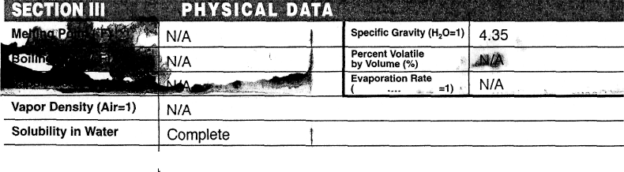
* chemical subject to the reporting requirements of SARA Title III.
Appearance & Odor Colorless, odorless liquid.
SECTION IV
Lower
Upper
Nonflammable
Flammable Limits in Air % by Volume
Flash Point (Method Used)
N/A
N/A
Use extinguisher media appropriate for surrounding fire.
Extinguisher Media
Special Firefighting Procedures
Firefighters should wear proper protective equipment and self-contained breathing apparatus with full facepiece operated in positive pressure mode.
| Unusual Fire and Explosion Hazards
Toxic gas of nitrogen oxides may be produced.

li^!?^
Stabi  Stable 3 | Ky?~t;'>:;y>* Unstable Q | Conditions to Avoid  Light | '
Incompatibility (Materials to Avoid) |  | Combustible materials, bromine trifluoride and trichloride, magnesium, phosphine, strong reducing agents.
Hazardous Decomposition Products |  | Oxides of nitrogen.
Hazardous P  May _{n} Occur ^ | olymerization  Will Not ,_ Occur ª | Conditions to Avoid  N/A
SECTION VII "• ::•',; .;••• •.- ' >.. SPILL OR LEAKPROCEPURES:t:ii.Ji^aaSiisaii^
. Steps jp_be'.Tal«gniln;ig|^ Take up with sand or otl
 |  | ier non<ombustJDleSsorbent material and containerize for
disposal. Flush spill area with water.
Waste Disposal , _ _{v} _ ,-_'._{1<a}_
Discharge, treatment, or disposal may be subject to Federal, State or Local laws. These disposal guidelines are intended (or the disposal of catalog-size quantities only
Dispose in accordance with ail applicable federal, state and local regulations,

SECTION VIII SPECIAL PROTECTION INFORMATION
Respiration Protection (Specify Type) | NIOSH approved dust/mist respirator if TLV exceeded.
Ventilation v i | Local Exhaust . | A |  | Specia
Ventilation v i | Mechanical (General) |  |  | Other
Protective Gloves | Rubber Gloves |  | Eye; Protection |  | Safety | Goggles
Other Protective Equipment | Lab coat.
SECTION IX SPECIAL PRECAUTIONS
precautions to be Taken in Handling & Storing
Keep container tightly closed when not in use.
Keep container out of light. Wash thoroughly after handling.

D.O.T. I Silver nitrate solution, 5.1, UN1493, PQII
Other Precautions
Read label on container before using. Do not wear contact !e: >::::s wnjn v,- s king with chemicals.
Do not get on skin or in eyes. Do not breathe|fumes or mist.
I
_
Approved by Steven C. Quandt I Effective Date
For laboratory use only. Not for drug, food or household use. Keep out of reach of children.

