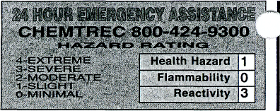
SARG&NT-W^LICH
i e n ? / / c
v w r
91 1 Commerce Court • Buffalo Grove • 1 ₅ 60CJ89-2375 •
1-800-727-4368 • ' I

material safety data sheet
•
READ CAREFULLY BEFORE USIN&CHEMICAL ; OSHA requires that this form be kep on file.
>roduct NO.C3163T ^{v} I
>roduct Name AMMONIUM NITRATE
Principal Hazardous Component(s) mmonium Nitrate
Not Established
'ail
Lower
Upper
N/A
Flash Point (Method Used)
Flammable Limits in Air % by Volume ___
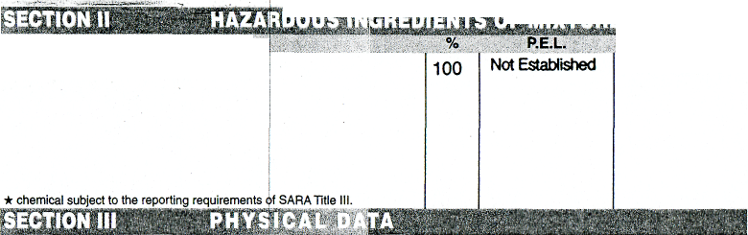
••SECTION 1 NAME
Chemical Synonyms | N/A
TE Formula | NH₄NO₃
C
A Q Mn | 6484-52-2

Melting Point (T) | 169°C | Specific Gravity (H₂0=1) | N/A
Boiling Point (T) | Decomposes at 210°C | Percent Volatile by Volume (%) | N/A
Vapor Pressure (mm Hg) | N/A | Evaporation Rate  ( 1) | N/A
Vapor Density (Air=1) | N/A
Solubility in Water | Very soluble
Appearance & Odor | Colorless to off-white prills; slight trace of ammonia odor.
N/A
N/A
Copious amounts of water.
Extinguisher Media
Special Firefighting Procedures i
:iremen should wear a self-contained USBM breathing apparatus md full protective clothing.

HEALTH HAZARD DATA
SECTION V
Threshold Limit Value
Not established. Nuisance dust: TLV-10 mg/m³ (total).
Effects of Overexposure
Eyes: May cause redness, pain and irritation to eye. Skin: May irritate skin resulting in reddening of
the skin and possible chemical bums, inhalation: Irritating to mucous membranes, respiratory tract,
causing sere trroat,coiighirKj,ciif^ Delayed reactions may
result in pulmonary edema and chemical pneuminitis. digestion: May cause gastric irritation, nausea, abdominal spasms and faintness. Large doses may cause systemic acidosis and methernogtobinemia. Chronic: Prolonged and repeated exposure may cause skin dermatitis, kidney damage and conjunctivitis.
Emergency and First Aid Procedures ; ~ 1 ~~
Inhalation: Not a likely route of exposure. Seek medical assistance. Skin Contact: Rush skin with water. Eye Contact: In case of contact, immediately flush eyes with plenty of water for at least 15 minutes including under the eyelids. Contact a physician immediately. Ingestton: If swallowed, induce vomiting immediately by giving two glasses of water and sticking finger down throat Never give anything by mouth to an unconscious person. Call a physician.

SECTION VI REACTIVITY DATA
Stabi Stable S | «y  Unstable Q | Conditions to Avoid |  High temperatures, open flame.
Incompatibility (Materials to Avoid) |  | Organic materials or explosives.
Hazardous '• Decomposition Products |  | Can include NH₃, NO₂₎ NO and N₂
Hazardous P  U^{ay} Q Occur ^ | olymerization  Will Not „ Occur *" | Conditions to Avoid v N/A
SECTION VII SPILL OR LEAKSPROCEDURES
Steps to be Taken in Case Material is Released or Spilled -
Sweep or scoop up spilled dry material. Flush area with copious quantities of water.
Waste Disposal Method ; ^ ; 3 • ~"~
Discharge, treatment, or disposal may be subject to Federal, State or Local laws. These disposal gu.dalines are intended for the disposal of catalog-size quantities only,
Spilled dry material or water solutions of ammonium nitrate can be distributed on land as fertilizer or flush away with copious amounts of water.
SPECIAL PROTECTION INFORMATION
RespirationnProtection (Specify Type)
NIOSH-approved respirator when exposure limits exceeded.
Local Exhaust
Special
Ventilation
Mechanical (General)
Safety goggles
Gloves
Protective Gloves
Eye Protection

• Other Protective Equipment F
Lab coat

Unusual Fire and Explosion Hazards j
turning of confined ammonium| nitrate could lead to detonation. Ammonium nitrate 5 a powerful oxidizing agent. Mixtures of this compound and organic matter are xplosive. Do not store in large quantities in an unventilated area, near an open ame, near heat, near organic materials or explosives.

SPECIAL PRECAUWM
Precautions to be Taken in Handling & Storing
Keep container tightly closed when not In use.
Keep away from heat, sparks and flame. Do not store near combustible materials.
Other Precautions .' ....•'.'•• '••/...'. "~ : * .,..'—,.....' •;.,•,•'•• '•• y ..••. "'. ~~ ' ~ ~ ~~
Read label on container before using. Do not wear contact lenses when working with chemicals.
Hygroscopic material retains moisture under some conditions and temperatures. Resulting puddles are a slipping probtern.

D.O.T. I Ammonium nitrate, 5.1, UN1942, PGIII
Approved by Steven C. Quandt Effective Date
For laboratory use only. Not for drug, food or household use. Keep out of reach of children.

The information contained herein is furnished without warranty of any kind. Employers should use this informaiion only as a supplemer

