103018-01

MAINTENANCE SUPPLY COMPANY* INC.
POST OFFICE BOX 498 HUNTERSVILLEV NORTH CAROLINA 28078

- MATERIAL SAFETY DATA SHEET -COMPLIES WITH USDL SAFETY AND HEALTH REGULATIONS* 129 CFR 1910,120
EMERGENCY PHONES { 704) 875-6513
MSDS REFERENCES 80920
REVISlDff DATES 4/24/36
% SECTION .1 - IDENTIFICATION

MANUFACTURED FOR:
product:
MAINTENANCE SUPPLY COMPANY* INC, POST OFFICE BOX 498 HUMT.ERSVILLE* N.C* 28078
» *•} .
DETERGENT

SECTION 2 ^HAZARDOUS INGREDIENTS

BOILING POI
SODIUM METASIL
5-10
h-'-^t physical
)ATA
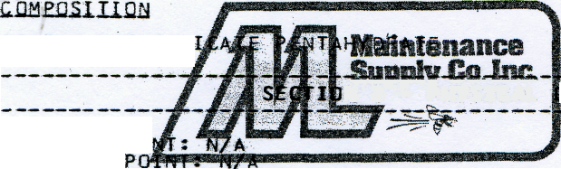
FREEZING
VAPOR .PRESSURE: N/A
VAPOR QPfslSITY: N/A
SOLUBILITY IN WAffR'rIPPf£ClAll"E
SPECIFIC GRAVITY, <H20=1): 0.83
PERCENT VOLATILE--BY VOLUMES < 1%
EVAPORATION RATE* {BUTYL ACETATE=1|: N/A
APPEARANCE AND ODOR: WHITE FREE-FLOWING POWDER
N/A

SECTION 4 - FIRE AND EXPLOSION HAZARDS

FLASH POINT: NONE AUTOIGNITION TEMPERATURE: FLAMMABLE LIMITS:
NONE

SECTION 5 - HEALTH HAZARD DATA
THRESHOLD LIMIT VALUE: N/A
EFFECTS OF OVEREXPQSURE: OVEREXPOSURE TO DUST MAY CAUSE NASAL AND RESPIRATORY IRRITATION. INGEST ION IN LARGE QUANTITIES CAN CAUSE HETASILICATE POISONING.
eyes: in case of eye contact, flush with water.
ingestign: if swallowed do not induce vomiting, give large quantities of water. give at least one ounce of vinegar in an equal amount of water, never give anything by mouth to an unconscious person, call a physician.

section 6 - reactivity'data
#
stability: stable
conditions to avoid: temperatures above 300 degrees c. hazardous polymerization: will not occur
conditions & materials to avoid: at temperatures' abqvt 800 degrees c*» toxic oxides of phosphorus may be given
OFF.
steps to be taken if material is released or spilled:
shovel up for reuse if not 8ad1y contaminated. may * be flushed to drain with large amounts of water.
waste disposal: flush to sewer with large amounts of water.
SeCTIon_8 * SPECIAL PROTECTION
RESPIRATORY PtQT£CTlON^*NON^TQXiC DUST MASKS MAY BE USED IF DUST
IS A"PROBLEM.
VENTILATION* NO SPECIAL VENTILATION NORMALLY REQUIRED. PROTECTIVE GLOVES: RU38ER GLOVES ONLY FOR PROLONGED CONTACT EYE PROTECTIONS SAFETY GLASSES
Section 9 - S PECIAL PR ECA UTIONS

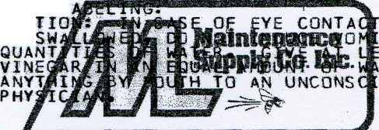
PRECAUTIONARY t
CA
if
FLUSH WITH WATER. . GIVE LARGE ONE OUNCE OF NEVER GIVE OUS PERSON* CALL A

