103018-01
MAINTENANCE SUPPLY COMPANY, INC.
POST OFFICE BOX 498 HUNTERSVILLEf NORTH CAROLINA 28078

- material safety data sheet -complies kith usol safety a*io health regulations* c *° cff* i91o.1200
emergency phone: (704) 875-6513 msds reference: 20060 revision date: 5/19/86
section 1 - identification

PRODUCT: TRADE NAME:
OMPANYt 28078
INC.
MANUFACTURED FOR
PLY C
SECTION 2 - HAZARDOUS/INGREDIENTS
> 50
10-20
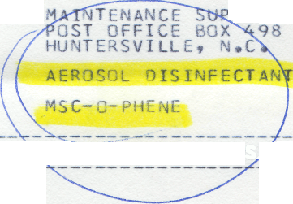
ETHYL ALCOHOL (CAS it 64-17-5)
PROPELLANT: C3-C4 ALKANE BLEND (CAS # 68475-59-2)
ILK
1000 PPM
800 PPM

SECTION 3 - PHYSICAL DATA (ON CONCENTRATE
BOILING POINT: APPROX. 180 DEGREES F. VAPOR PRESSURE (MM HG ) : 30 3 20 DEGREES C. VAPOR DENSITY (AIR=1): 1.06 SOLUBILITY IN WATER: APPRECIABLE
SPECIFIC GRAVITY, (H20=l): 0.87
PERCENT VOLATILE BY VOLUME: APPROX. 99
EVAPORATION RATE, < B, AC ET.=1 ) : OVER 1.0
APPEARANCE AND ODOR: CLEAR THIN LIQUID PLEASANTLY P-fPFUMEO
SECTION 4 - FIRE AND EXPLOSION HAZARDS
FLASH POINT (METHOD USED): 73 DEGREES F» (T.U.C.); " DEGREES
F. (T.C.C.) (ON CQNC.) FLAMMABLE LIMITS: LEL-4.3, UEL-19
EXTINGUISHING MEDIA: WATER FOG_{f} C02, DRY CHEMICAL SPECIAL FIRE FIGHTING PROCEDURE: KEEP CONTAINERS CO)'. USE
SHIELDING TO PROTECT PERSONNEL AGAI?siST BURS^INGf
RUPTURING OR VENTING CONTAINERS. UNUSUAL FIRE AND EXPLOSION HAZARDS: AT ELEVATED TEM»R*ATURES»
(OVER 130 DEGREES F.) CONTAINERS MAY VENT* ^{P}UPTURE»
OR BURST.
SECTION 5 - HEALTH HAZARD DATA
threshold limit value: over 1000 ppm effects of overexposure:
eyes: causes temporary eye irritation.
ingestion: symptoms same as alcohol intoxication,

