IAINTENANCE SUPPLY COMPANY, INC.
POST OFFICE BOX 498 HUNTERSVILLE* NORTH CAROLINA 28078
- MATERIAL SAFETY DATA SHEET -COMPLIES WITH USOL SAFETY AND HEALTH REGULATIONS* (29 CFR 1910*12(

emergency phone msds reference: revision date:
13530
375-6bl3

SECTION 1 - IDENTIFICATION
fl^IiuT£WA,MCc SUPPLY SERVICE CORPORATION
P • j S T i j F >-~ I C P ': U X 498
tiUNTERSVl'LLi* NORTH CAROLINA 28078
PRODUCT: ftaUcGUS SILICONS SOLUTION
TRADE NiAME: JET STREAM DEFOAWER
SECTION 2 - HAZARDOUS INGREDIENTS
THE COMPONENTS OF,,JET STREAM OEFGAMlEP ARE NUT CONSIDERED HAZARDOUS UNDEK CUPRE14T f: tGULATI tWS», ;•
SECTItDN 3 - PHYSICAL )ATA
____^_
«_ »»JW BBHIIl'-¹' "*.'••,..- \ '~'
BOILING POIjlr:TT2TEGR$£S £.__,.
SOLUBILITY
SPECIFIC GRAVITY, (H20=1): 1.0
PERCENT VOLATILE 3Y VOLUME: 95
P H : 3.7
APPEARANCE AND OOOR: MILKY SOLUTION WITH LITTLE ODOR
SECTION 4 - FIRE AND EXPLOSION HAZARDS
NUT FLAMMABLE SECTION 5 - HEALTH HAZARD DATA
THRESHOLD LIMIT VALUE: VOT r 3^{T} A : L I S^{w} 2 D PRIMARY ROUTES OF INT3Y: SxlN ABSORPTION
EFFECTS OF DVEREXPUSU^E:
SKIN: PCSSIriLv: IRRITANT EYES: POSSIBLE I^>:ITA',T
MEDICAL CONDITION AGGRAVATED 3Y EXPOSURE: PREVIOUSLY EXISTING '•
SKIN GK EYE PhOdLEMS
£M£E££NC_Y JE1BSI aid PRQ££OUB.£l
SKIN: WASH AFFECTED AREAS WITH WATER; IF IRRITATION PERSISTS, CONTACT A PHYSICIAN.
EYES: FLUSH WITH WATER FOR 15 MINUTES; CONTACT A PHYSICIAN.
THE CHEMICALS CONTAINED IN THIS PRODUCT ARE NOT CURRENTLY LISTED AS CARCINOGENS.
SECTION 6 - REACTIVITY DATA
stability: stable
HAZARDOUS POLYMERIZATION: .-,'ilL fvQT OCCUR I INCOMPATIBILITY: NONE
SECTION 7 - SPILL OR LEAK PROCEDURES

SPILL OR LEAK PRECAUTIONS:
SMALL SPILLS: LARGE SPILLS:
WASTE DISPOSAL:
FLUSH MATERIAL DOWN DRAIN WITH LARGE "AMOUNTS
OF WATER* , -
USE CHEMICAL ABSORBENT TO SOAK UP MATERIAL. DISPOSE OF >IASTE AT AN APPROVED LANDFILL IN ACCORDANCE WITH STATE REGULATIONS.
FOLLOW STATE AND LOCAL REGULATIONS FOR DISPOSAL
OF LARGE NON-RECLAIMABLE SPILLS-
SECTION 8 - SPECIAL PROTECTION
protective gloves: recommended when handling concentrate. eye protection: keco;im:n&^{c}::o when handling concentrate.
section 9 - precautions: handling, storage and usage

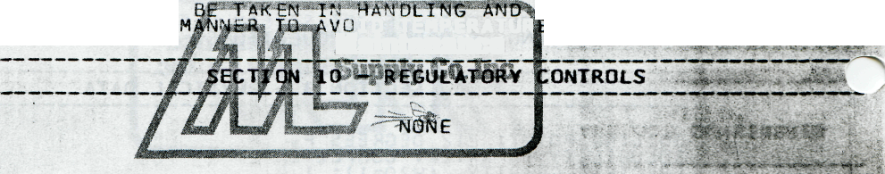
STORAGE: STORE MATERIAL EXTREMES.
PRECAUTIONS TO IN A
, Q TEMPERATUR
Maintenance

