V W R SCIENTIFIC
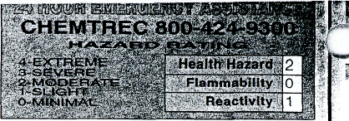
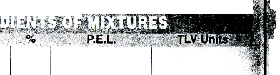
911 Commerce Court • 3rove • Illinois 6SQ89-2375
1-_{t} -4368
MATERIAL SAFETY DATA SHEET
EAD CAREFULLY BEFORE USING CHEMICAL
SHA requires thai this form be kept on file.
roduct No. C4474R
roduct Name POTASSIUM IODIDE
principal Hazardous Component(s)
ine ine

I^SiOi^H
Chemical Synonyms | None
Formula | Kl
C.A.S. No. | 7681-1 | 1 -0
Emergency and First Aid Procedures
\ .SKIN: Wash exposed area with soap and water. Get medical advice if irritation occurs. EYES: Wash eyes i/vyith plenty of water for at least 15 minutes, lifting lower and upper eyelids occasionally. Get medical attention |irnrnediately. INHALATION: Remove to fresh air. If not breathing, give artificial respiration. If breathing is Idffficult, give oxygen. Call a physician. INGESTION: If swallowed, induce vomiting immediately by giving two glasses of water and sticking finger down throat. Never give anything by mouth to an unconscious person. " Call a physician immediately.
ACUTE: Irritation to skin, eyes, lungs, mucous membranes and Gl tract. CHRONIC: " lodism", headache, runny nose, weakness.
Conditions to Avoid;
None
Unstable Q
Stable

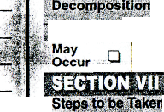
r chemical subject to the reporting requirements of SARA Title III.
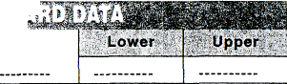
----- ••~--:
; .' I
/letting Point (T)
Specific Gravity (H₂0=1)
723°C
3.1
toiling Point (*F)
Percent Volatile by Volume (%)
1420°C
N/A
Evaporation Rate
'apor Pressure (mm Hg)
( =1) N/A
N/A
N/A
'apor Density (Air=1)
Extremely
iolubility in Water
White crystals, no odor.
ippearance & Odor
7 T^T^V^TC iv
- -TT^-^nssTwwT-'i-TTr-^ t^tst*
#v U,X^ *M4K
N/A
lash Point Method Used)
Flammable Limits in Air % by Volume
Use any medium suitable for extinguishing supporting fire.
ixtinguisher ledia
ipecial Firefighting Procedures
the event of a fire, wear full protective clothing and NIOSH-approved breathing jparatus with full facepiece operated in the pressure demand or other positive essure mode.
Mixed halogens, diazonium salts, calomel.
Iodine and iodine fumes.
Conditions to Avoid None
(Materials to Avoid)
> '' . *i .. . . '
, Hazardous;,':;,
; Products
Hazardous Polynnerlzatiori
' "
will Not
Occur-
i in Case Material is Released or Spilled
Remove all sources of ignition. Ventilate area of leak or spill. Clean-up personnel may require protection from inhalation of dust. Spills: Clean up in a manner that does not disperse dust into the air.
.. ..
Discharge, treatmern. or disposal may be subject to Federal. Slate or Local laws. These disposal guidelines are intended for the disposal ol catalog-size quantities only.
Disposal: Whatever cannot be saved for reclamation may be disposed in a RCRA-approved waste facility. Do not flush to the sewer.

 | ffHTTTnTST-'Fi «$'•>'  KA^-ft^J&MU | -^^V^^rf-fe A | ;i „,<«!!. »'*#c»
, Respiration {Protection  (Specify Type) tu , | Dust
' " ' ?v' " | 1 Aral Fvhnnttt V | •
. |y ™ Tjfjj'j^A - | Mechanical (General) :< | Othe | r
Protective Gloves ' - ' | Vinyl or Rubber | Eye Protectior | i Safety glasses
Other Protective" ./' | Lab coat

'nusual Fire and Explosion Hazards :
ot considered to be a fire hazard. Not considered to be an explosion hazard.
Precautions to be Taken in Handling & Storing
Keep container lightly closed when not in use.
Store in dry location.

Other Precautions
Read label on container before using. Do not wear contact lenses when working with chemicals
Conditions Aggravated/Target Organs: None known.

O.T. Not Regulated
Approved by Steven C. Quandt
Effective Date
02/13/95
For laboratory use only. Nol for drug, food or household use. Keep out of reach of children.

iroved by U.S. Department ot Labor "essentially similar" to form OSHA-20
The information contained herein is lumishsd without warranty of any kind. Employe's should use this inlormalion only as a supplement lo other inlomiation gathered by Ihem and must make independent determination o< suitability and completeness o( information (corn all sources to assure proper use ot these materials and the satety and heaWh o1 employees.

