ESSROC Materials Inc.
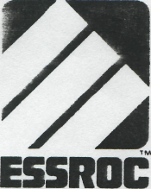
Southern Cement Division 1001 N. Hoskins Road Charlotte, NC 28216 704-393-9221
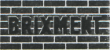

March 22, 1993
B. E. Kluttz Lbr. Co., Inc. 975 Davidson Drive NW Concord, NC 28025
ATTENTION: Carolyn Kluttz

Fineness-Passing 1325 Sieve, Autoclave Expansion* X
ASTM C-91 Teat Report on Brixroent Masonry Cement-Type S
Typical
Test Results
97 .03
C-91 Requirements
76 Minimum 1i0

'hra. Minimum hra. Maximum
3 hra. 50 mine. 6 hre. 45 nins.
Time of Setting - Initial
Final
24
8-20
70 Minimum 110 +/- 5
17
83 111
Air Content* 2 Water Retention, % Original Flow of Mixture. Z Compraaaiva Strength, FSI
7-day* 28-daya
1,700 2.500
1,300 Minimum 2.100 Minimum
Thia la to certify that Brixroent-Type S Masonry Cement meeta the requirements of ASTM C-91 Standard Spacification for Masonry Cement Type S.
Sincerely,
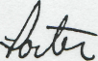

James M. Porter Director of Sales Southeast Package
JMP:sw
Subscribed and sworn to before me this
22nd day of March, 1993,

NORATY PUBLIC
My Commission Expires 10'24-94

