"OFFICE BOX 498 HUNTERStflLLE* MORTH CAROLINA 23078
- MATERIAL SAFETY 0ATA SHEET - /
COMPLIES WITH ySOL SAFETY A1!> HEALTH R£GULATIOItS» 129 CFR 1910*120$
C704) 875-6513
MSBS REFERENCES RtlffSt« BATES
SECTION1 - I DENT IF I CAT I ON

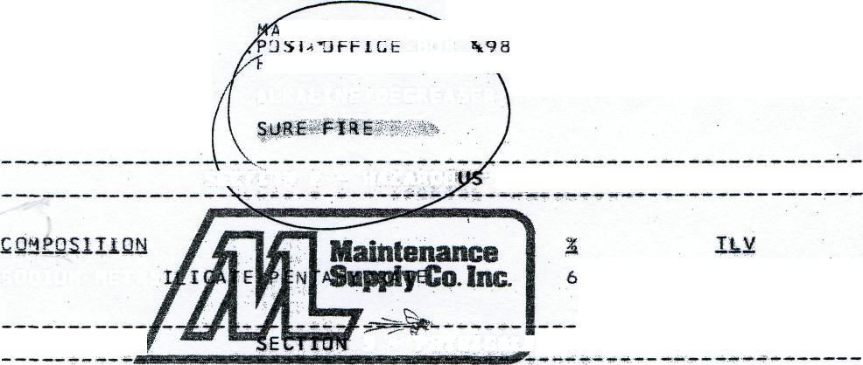
,INTE^AMCE SU><LY SERVICE CORPORATION
BOX lUNTERSV'lLLE, '.MORTH CA3,dLINA 28078
MANUFACTURER
PRODUCT: TRADE NAHE:
ALKALINE-0EGREASER
INGREDIENTS
SECTION 2 - HAZARDO

SOOIUM METAS
NOT ESTABLISHED L050 800 MG/KG ( R AT J
3 * THYSICALJOATA

BOILING POINT: 212 DEGREES F.
SOiUSItlTY ..... I-M- WATES2- 100-%- ...... •• ..... • ......... •• • ..... - ..... • •- ..... ..... •- .......... ......
SPECIFIC GRAVITYt «H20=1.5s 1.0
PERCENT VOL4TILE BY VOLUME: 38
P H : 12.7
APPEARANCE AND ODOR: TURQU3ISE LIQUID WITH LEMON ODOR
SECTION 4 -FIRE ANDEXPLOSIOiStHAIARS
FLAMMABLE
SECTION 5 - «EMLT« HAZARD DATA
THRESHOLD LIMIT VALUE: MOT ESTABLISHED
PRIMARY ROUTES OF ENTRY: S<IM ABSORPTION; IMGESTION
EFFECTS OF OVEREKPOSURE : EYES: SEVERE IRRITANT SKIM: SEVERE IRRITANT INGEST JON: SEVERE GASTROINTESTINAL DISTRESS
MEDICAL CONDITIONS AGGRAVATED BY QVEREXPOSURE: PRIOR SKIN, GASTROINTESTINAL DISORDERS
EYES: FLUSH V^ITH (*ATER FDR 15 MINUTES; SEE A DOCTOR IMMEDIATELY.

SKIN: FLUSH WITH WATER FOR 15 MINUTES. IF IRRITATION
persists* contact a physician,
ingest ion: drink large qjamtities of milk or water,
00 not induce vomiting, go immediately to emergency room of hospital*
chemjcals in this product a^e not currently listed as
carcinogens.
section 6 -_reactivity data
stability: stable
hazardous polymerization: will mot occur
incompatibility: agios
section 7 - spill or leak procedures
FLUSH INTO DRAIN WITH LARGE QUANTITIES OF HATER*
SPILL OR LEAK PRECAUTIONS: SHALL SPILLS:
USE ABSORBENT MATERIAL TO SOAK UP MATERIAL. DISPOSE OF WASTE AT APPROVED LANDFILL IN ACCORDANCE HITH STATE REGULATIONS.
LARGE SPILLS:
FOLLOW STATE AND LOCAL REGULATIONS FOR DISPOSAL OF LARGE NDN-RECLAIMABkE SPILLS.
disposal;
SECTION 8 * SPECIAL PROTECTION

SECT I
PROTECTIVE GLO
EVE 'PROTECT 10.
QTHER PROTECtV HAISPL

NCENTRATE
GGLES 1^ HANDLING
IS RECOMMENDED WHEN
STORAGE AN9 USAGE

PRECAUTIONS TO Bt TAKEN IN riAMDLING AND STORAGE: STORE AWAY FROM .-'•• . ACIDS.
OTHER PRECAUTIONS: IF CONCEMTRATE IS SPILLED ON CLOTHES? WASH THOROUGHLY BEFORE 5EEUSE*
SECTIOM 10 »- REGyLATORt CONTROLS
department of transportation:
dot classification:'corrosi/e
dot proper shippin3 nam-e: corr ssi ve ^{v}li quid mos
OTHER DOT iNFORMATIOM: !JM 1T&0 ^{v}

